**Welcome to Front-End Web UI Frameworks and Tools: Bootstrap 4**

Welcome to front end Web UI Frameworks and Tools: Bootstrap 4.

I'm glad you decided to join this course to learn

about the most popular front end Web UI Framework: Bootstrap.

We'll look at various aspects of Bootstrap. Through several examples, you will learn by doing exercises as part of this course.

Let's look at some details next.

Before you begin this course,

please make sure that you have sufficient background to

be able to succeed in this course. You should have a good knowledge of HTML, CSS, and JavaScript before you start the course.

From my perspective, web design and development consists of two aspects:

one is the design of the website and the web page,

the second one is the actual building and deployment of the web page itself.

From the design perspective, what I mean is the design of the user interface and the user experience, the visual design, the prototyping, the elements of colors, graphics and animation that might be of interest.

In this Specialization, we are not looking at this aspect of web development. Instead, we are looking at that second aspect, which is the development, building, and deployment of websites and web pages, using technologies like the front end web UI frameworks like Bootstrap, maybe JavaScript framework like Angular or a Library like React and hybrid mobile frameworks to design mobile applications and also server-side development using Node, Express, MongoDB, the main stack in more detail.

If you are looking at the Specialization, thinking about the design aspect of website, then you may wish to rethink again.

This Specialization concentrates on the development building and deployment of website and web pages,

a purely technical knowledge on using the HTML,

CSS, and JavaScript-based skills for actual website development.

You're also probably wondering about what is meant by full stack web development.

We'll look at more details of full stack web development in the next lesson.

In particular, if you're looking at how this course is

positioned in the general context of full stack web development, in this course, we are dealing with front end web UI development.

In particular, the UI Framework Bootstrap 4. We'll be looking at the remaining aspects of full stack web development in the rest of this specialization.

This course looks at Bootstrap in great detail. We will also look at responsive web design and how Bootstrap supports responsive web design through the Bootstrap Grid system.

We'll look at the CSS and JavaScript-based components in Bootstrap and how you can make use of them in building your website and your web pages.

Along the way, we'll learn about that web development using the command line. So we'll learn a lot of web tools that are based on the command line and the Node.js ecosystem. We'll briefly review Git, add Node.js and look at Noje.js based tools including task runners like Grunt and Gulp.

This course, itself, is structured into full modules. Each module roughly corresponding to one week of work.

In the first module, we'll get the big picture view of full stack web development, then you'll get a quick introduction to Git and Node.js. Then we'll introduce you to the Bootstrap and then review the Bootstrap Grid system. That will lead you up to the first assignment in this course.

The second module deals with Bootstrap CSS components. We'll look at the design of the Bootstrap navigation bar and how we can make use of it to support navigation. We'll look at user input through

buttons and forms then we'll look at how we can displaycontent using tables and cards. Then we'll look at how we can include images and media into our Web page using images, thumbnails, and media objects. And then, finally, we look at how we alert users using tags,

alerts and progress bars. This should lead you up to your second assignment.

The third module deals with Bootstrap JavaScript components. We'll look at the big picture view of

how Bootstrap JavaScript components work, we'll review tabs, pills and tabbed navigation, then we'll look at how collapse and accordion can be used to show and hide content. And then we'll look at the use of tooltips,

popovers and modals to reveal content to be displayed in your page.

And then we'll look at the carousel component, which allows you to display sliding information on your web page. This should lead you up to the third assignment in this course.

The last module deals with Bootstrap and the JQuery and various dev tools. We'll, in particular, look at how Bootstrap and JQuery interact and how you can

write JQuery and JavaScript code in order to control your Bootstrap JavaScript component. We look at the various methods that are supported by the Bootstrap JavaScript components, which can be leveraged (kisi kaam ke liye sufficient power) to write JavaScript code to control the behavior of these components. Then we'll review CSS pre-processing language is like LESS and Sass. Then, finally, we'll look at how we can build and deploy our website using NPM scripts or task runners like Grunt and Gulp. This should take you all the way to the final assignment in this course.

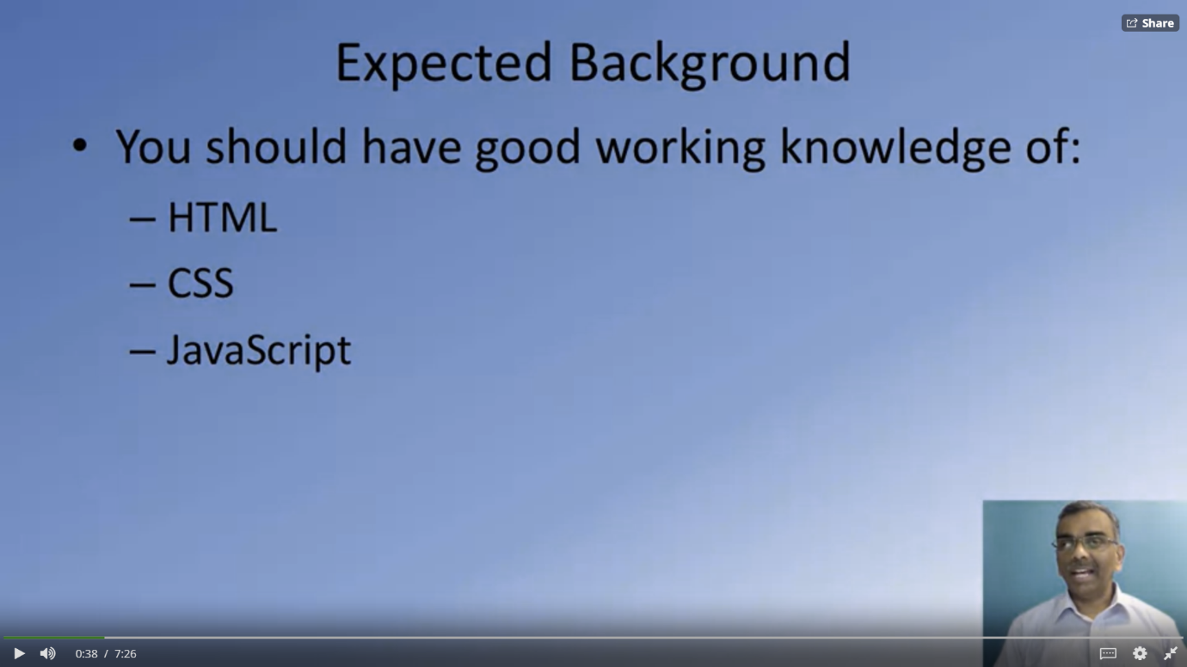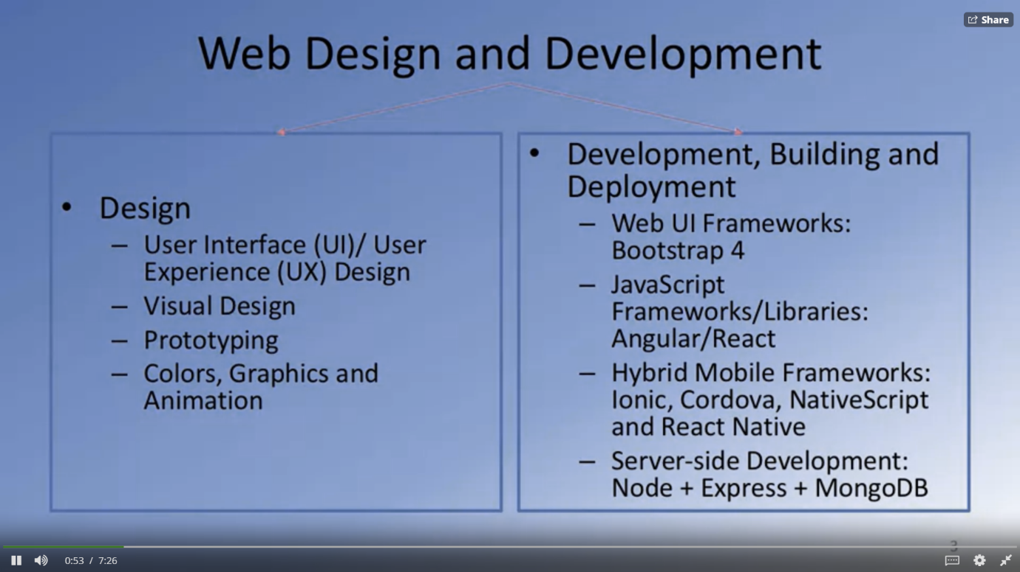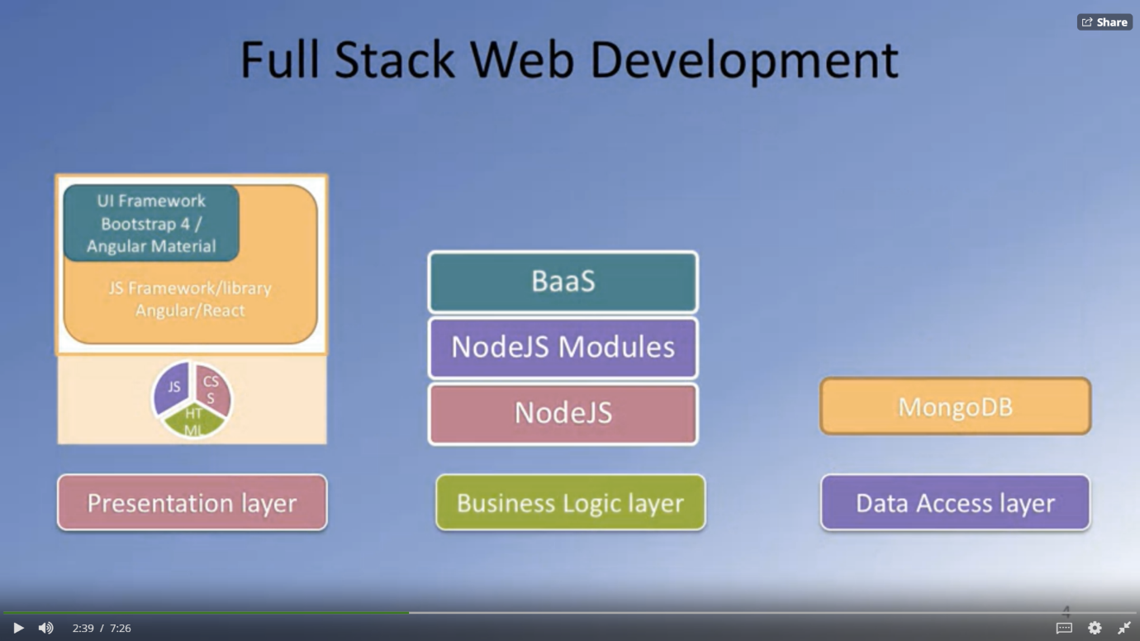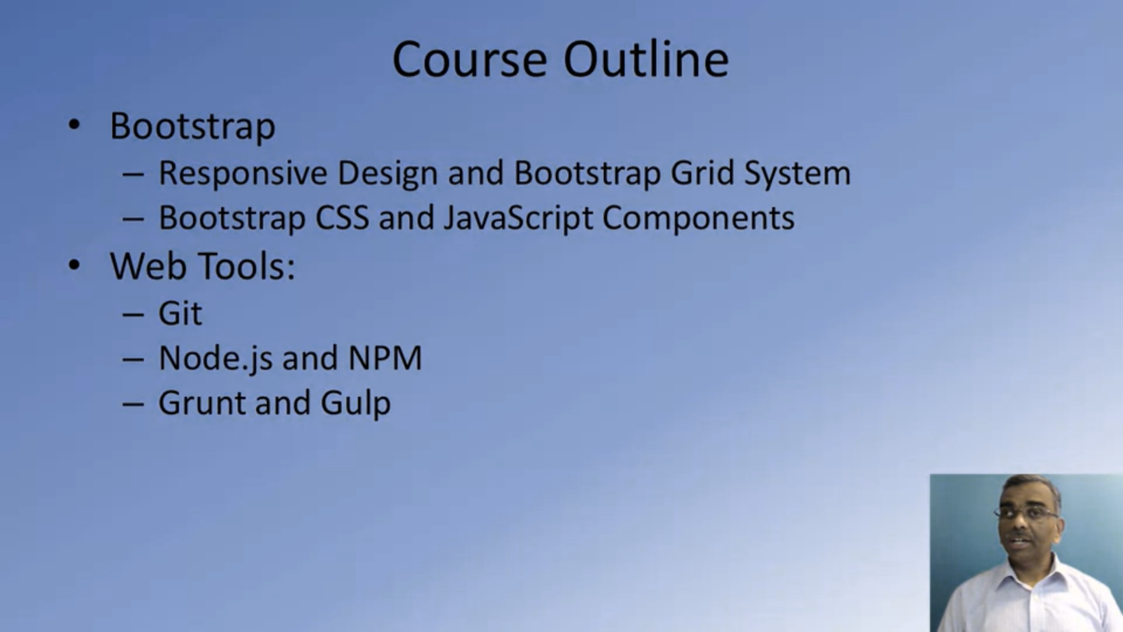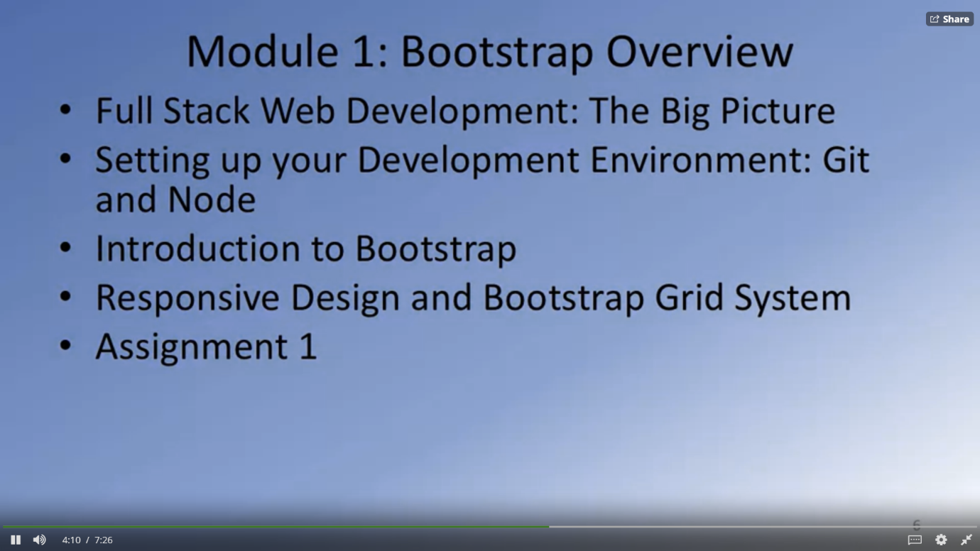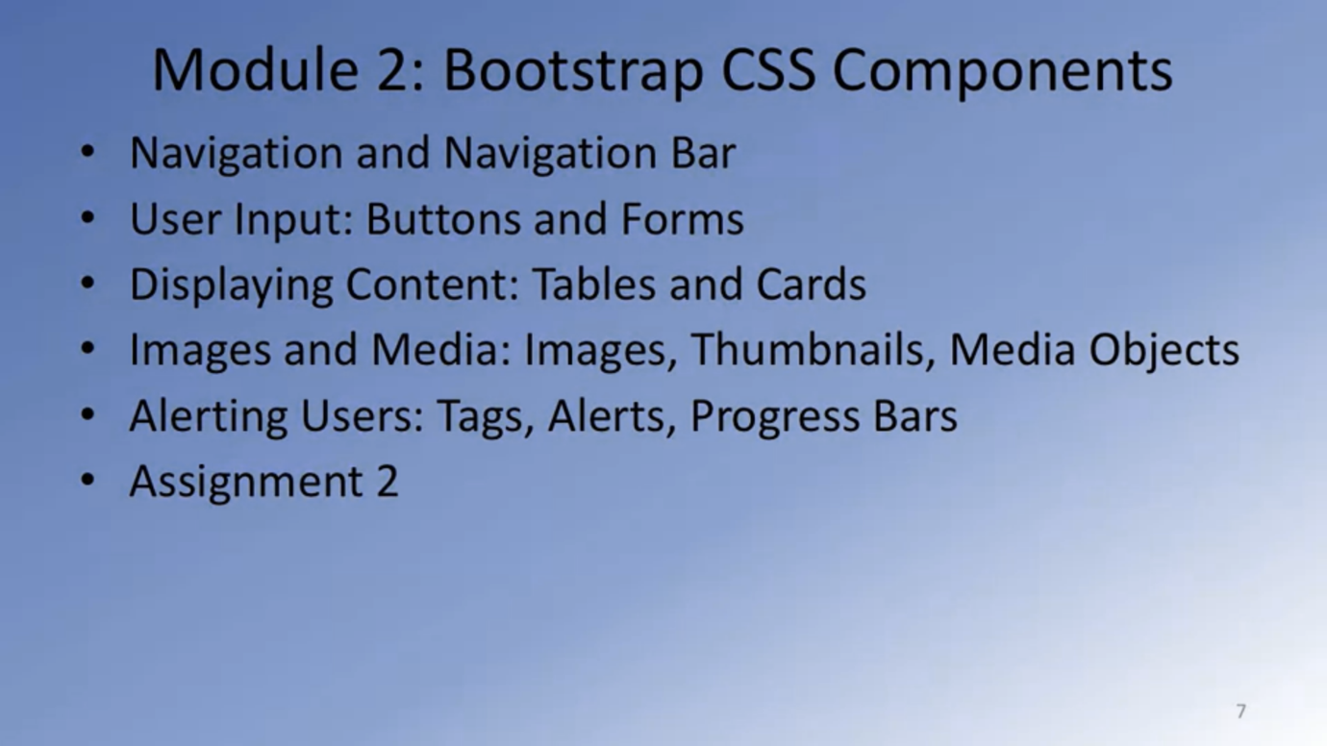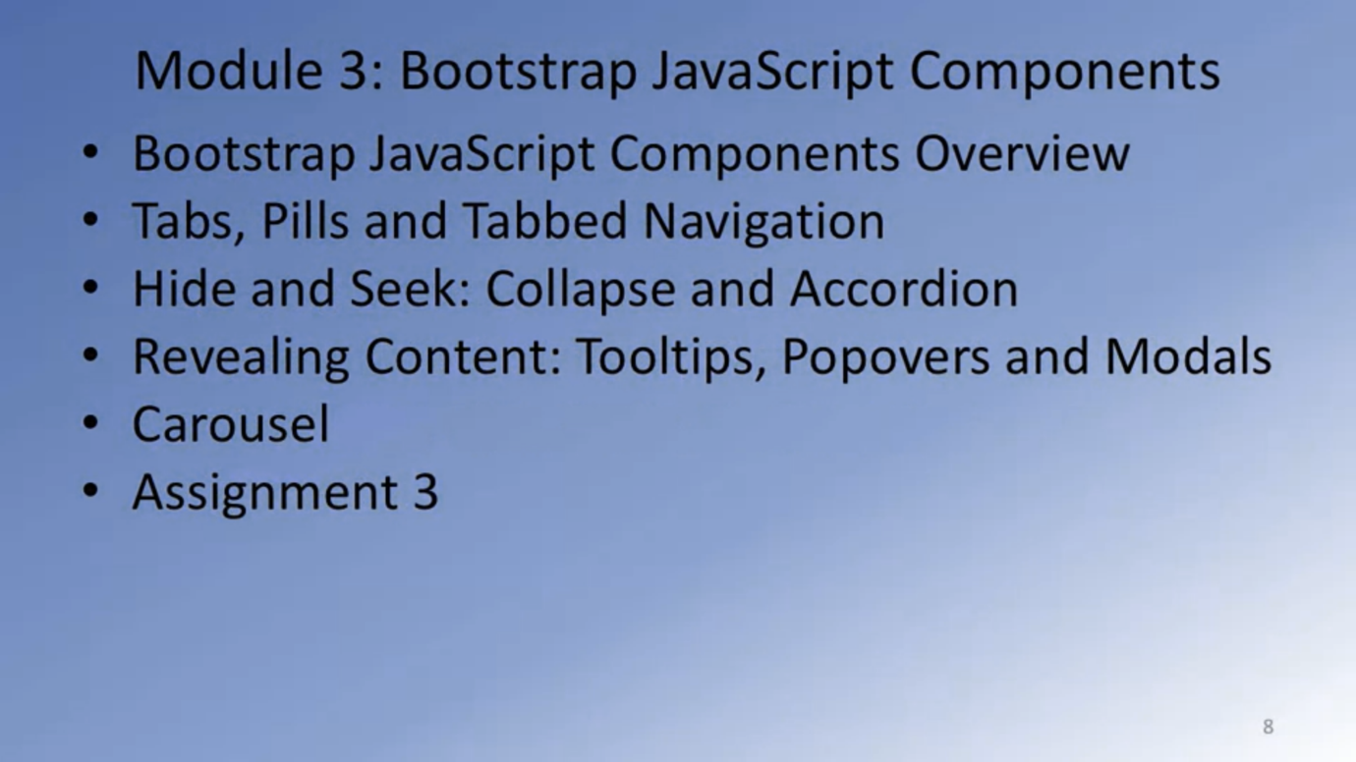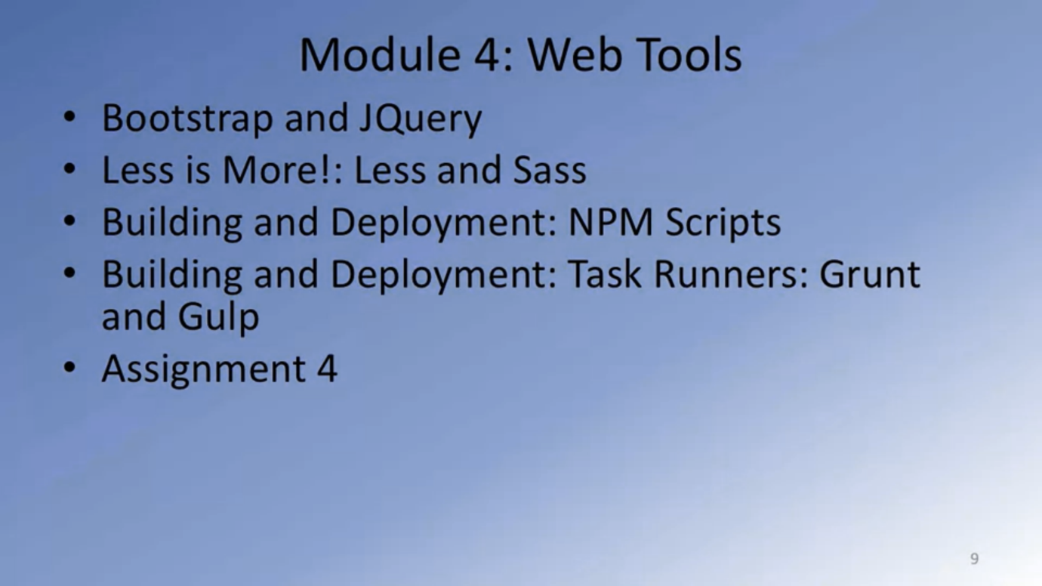

# **Use the Learning Resources How to use**

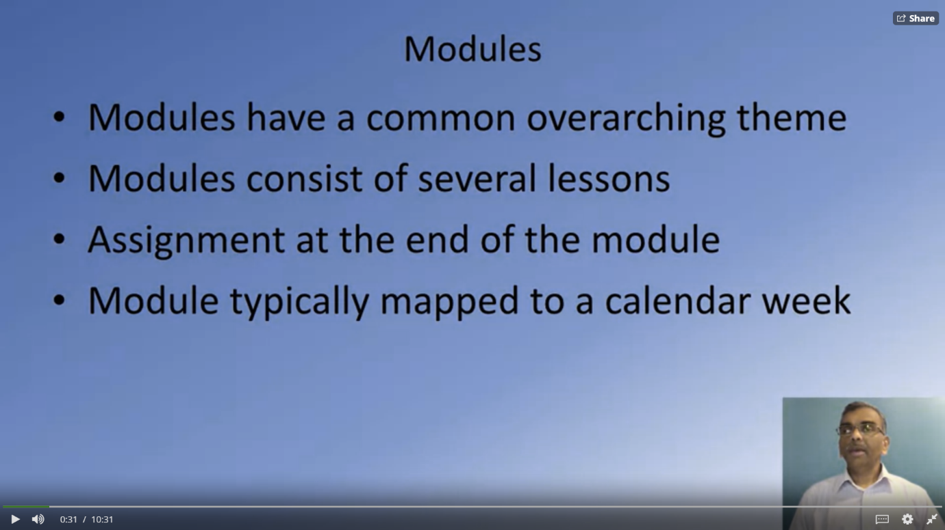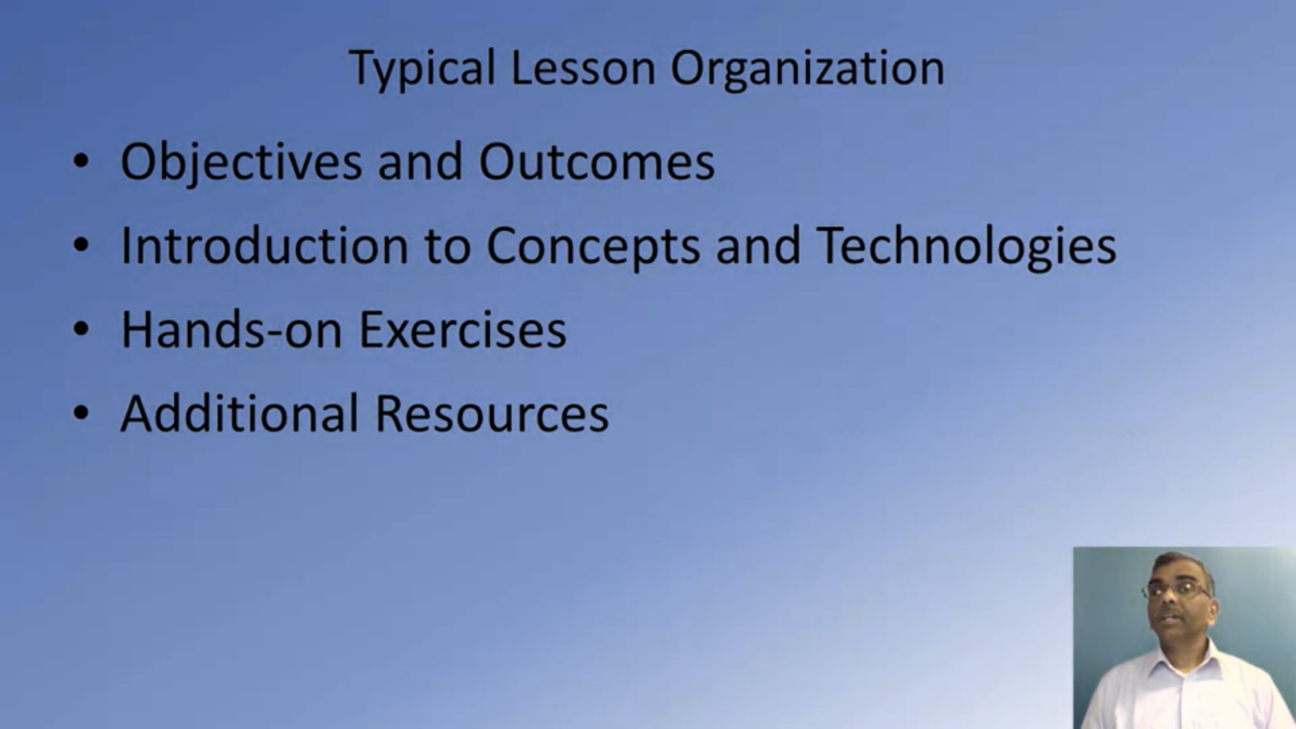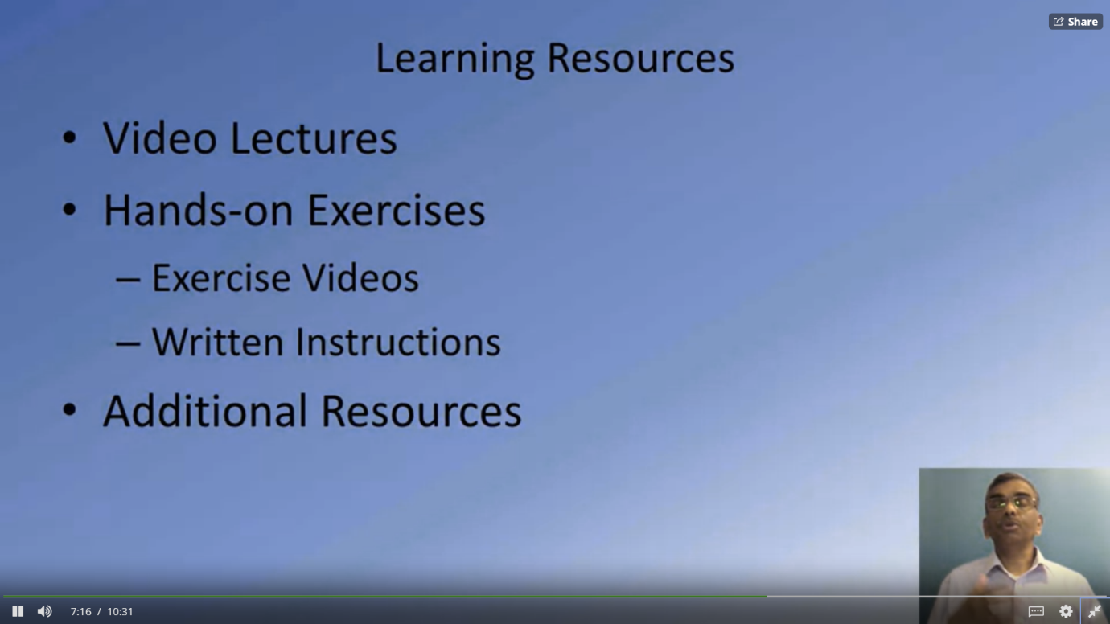

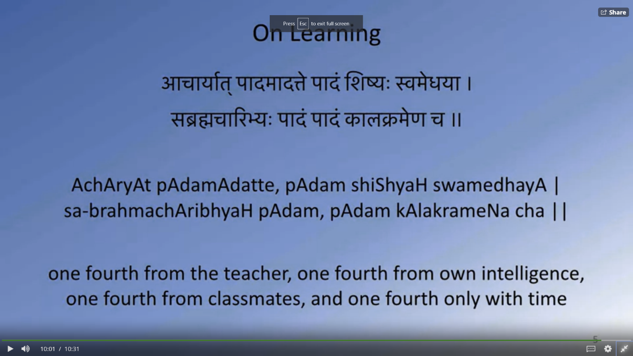

# **Welcome to Front-End Web UI Frameworks and Tools: Bootstrap 4: Additional Resources**

### Bootstrap Resources

* [Bootstrap Site](http://www.getbootstrap.com/)

### Coursera Resources

* [Coursera Learner Help](https://learner.coursera.help/hc/en-us)
* [Switching to a Different Session](https://learner.coursera.help/hc/en-us/articles/208279776)

# **Full Stack Web Development: The Big Picture**

What is Full Stack Web Development? Let me clarify to you a few terms So, that we started a common understanding of full stack web development as applied in this special session. We often hear people talking about the frond end and back end.

The frond end is where we are delivering the content to the user, typically, in a browser where they use accesses the information, and this is where we use technologies like HTML, CSS and JavaScript to render the content for to the user.

This information delivery is supported behind the scenes by a back end support which is typically implemented these days using technologies like PHP, Java, ASP.NET, Ruby, Python or NodeJS.

We often hear people talking about the three tier architecture for Web Development. In this approach, the entire web application is organized into three different layers.

The presentation layer, which is concerned with delivering the to the user, So, this is usually the UI-related concerns that are dealt with at the presentation layer.

The Business Logic Layer, on the other hand, is concerned more about the data, the data validation, the dynamic content processing, and generating the content to be delivered to the user.

This is backed up behind the scenes with the data persistence layer or the data access layer. So, this is concerned with how we store and interact with the data, typically, in the form of a database and access this data through an API.

Exploring this further, let us see what is implemented typically in the traditional web development in each of these three layers.

The Business Logic Layer is usually implemented these days using technologies like Ruby, Python, PHP, JAVA, C++ or ASP.NET.

This Business Logic Layer is interacting behind the scenes with

the persistent data typically stored in a relational database and accessed by the Business Logic Layer. The Business Logic Layer is also concerned with the rendering of information to the front side, typically, in the form of server-side rendering these days.

So, the HTML, CSS and JavaScript is generated on the server-side and then sent over to the client side in the form of a web page.

In this approach, we need specialists in each of these three layers.

So, frond end specialists, typically, would be well-versed in HTML, CSS, and JavaScript.

The business logic specialist would be well-versed in one of the technologies that is used for implementing the business logic and then you need a data specialist who will be well-versed in the relational database management system.

There is an increasing trend towards using a single language to implement the entire stack, this being JavaScript so you could have the frond end implemented,

for example, as a single page application using frameworks like Angular or React. You have the server-side or the Business Logic Layer being implemented using technologies like NodeJS, which is also dependent on and JavaScript and then you have the data storage, itself, being implemented using technologies like MongoDB,

which stores data in the form of JSON documents.

And the information exchange between the server side and the client side is usually done using JSON as the format and the server side supports a REST API endpoint.

We will cover these technologies as part of this specialization.

So, as you go through the specialization, you will see that on the presentation layer side, we will cover Bootstrap four and Angular or

React for implementing frond end applications while on

the Business Logic Layer we will be using NodeJS and NodeJS modules

and express for implementing the Business Logic Layer.

We will also consider back end as a service and Then the data support implemented using MongoDB.

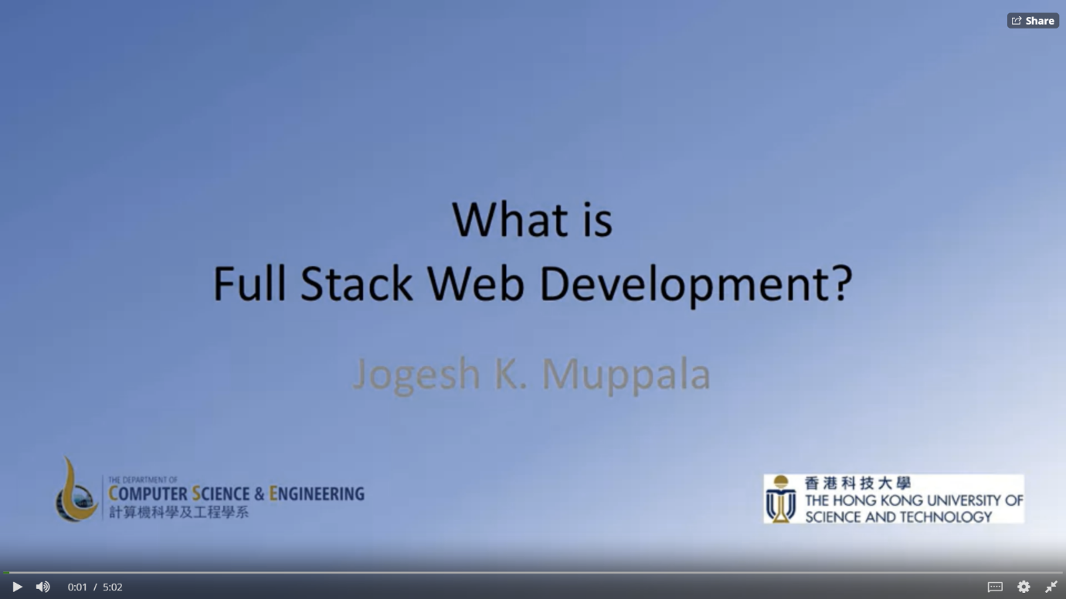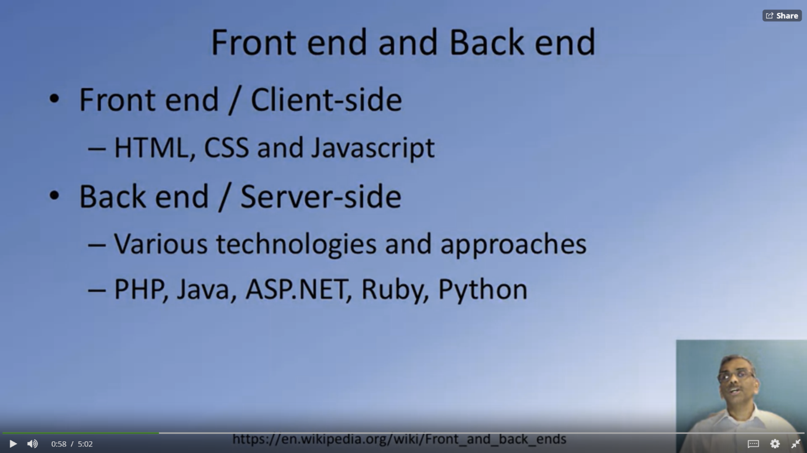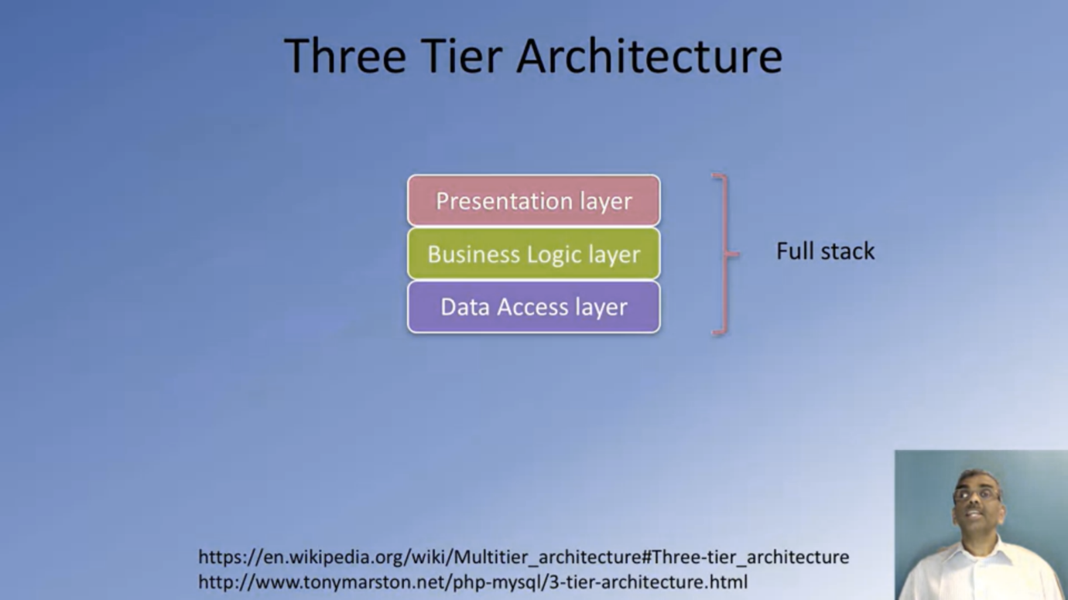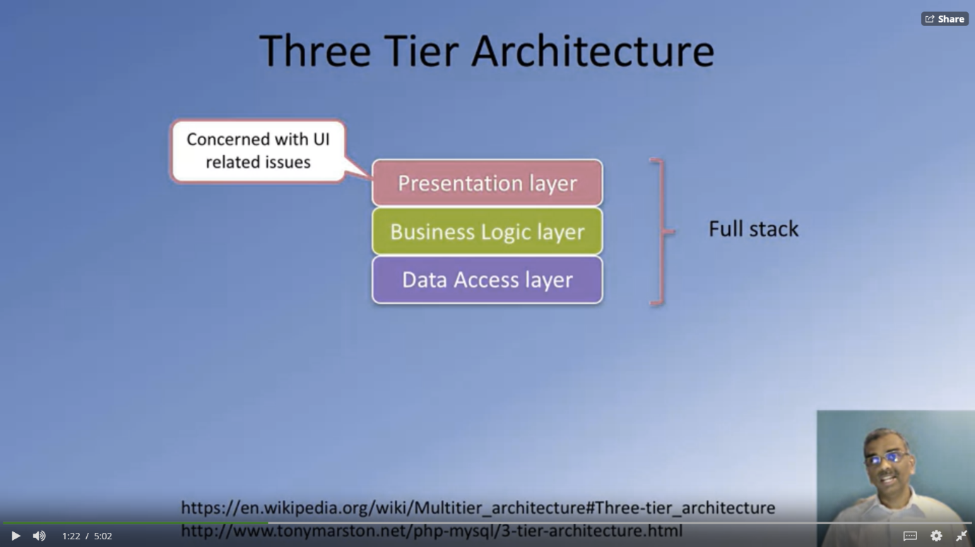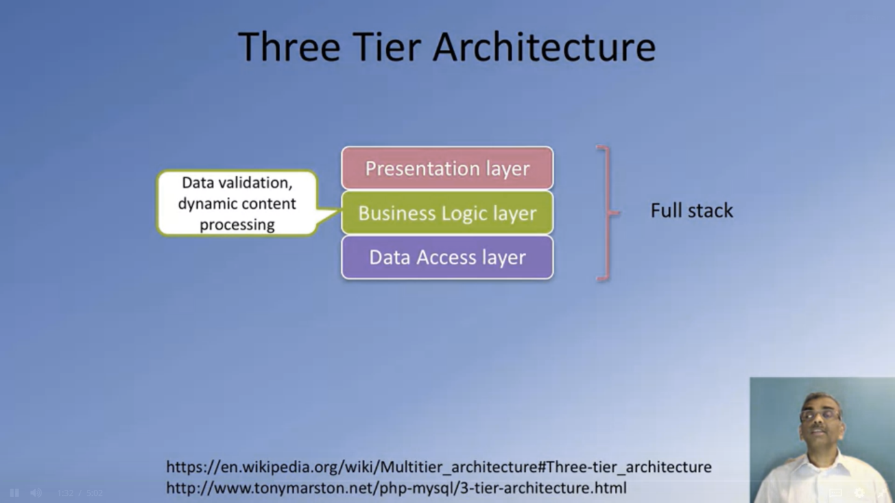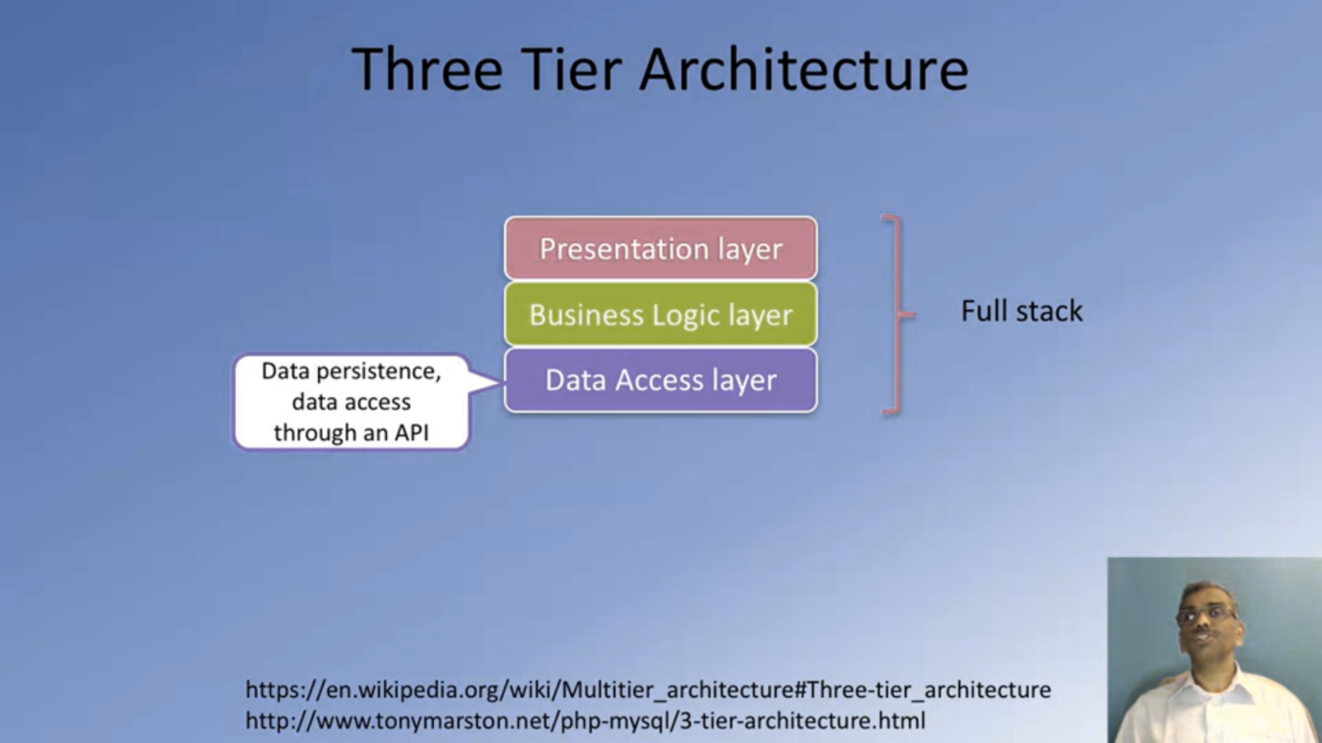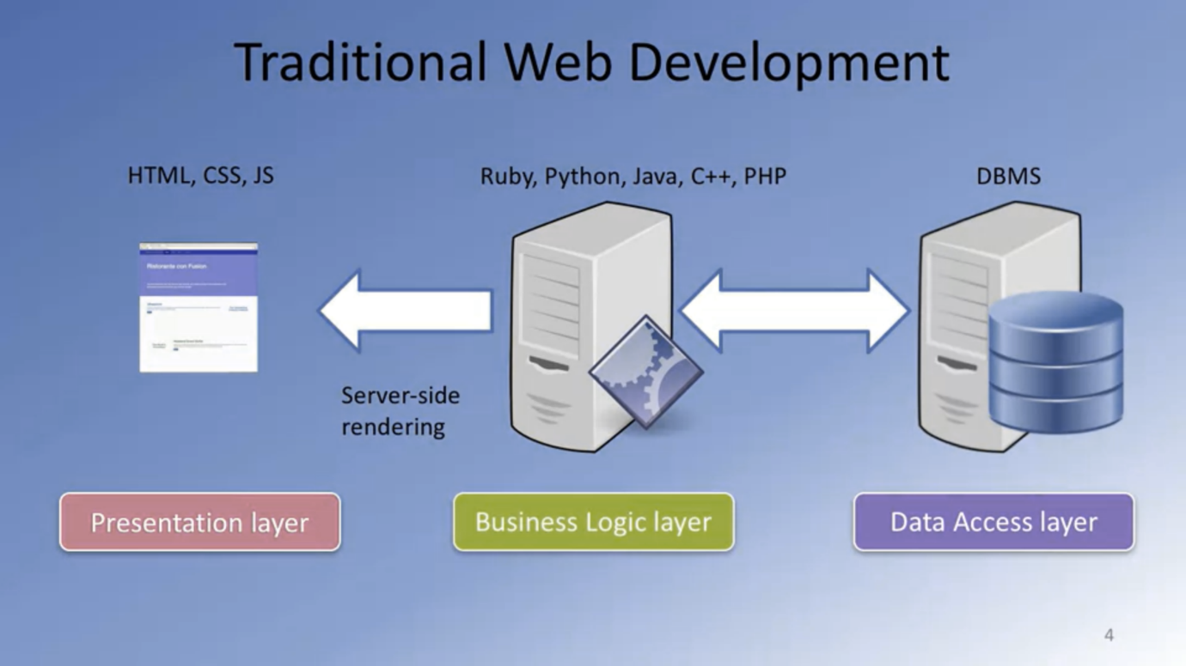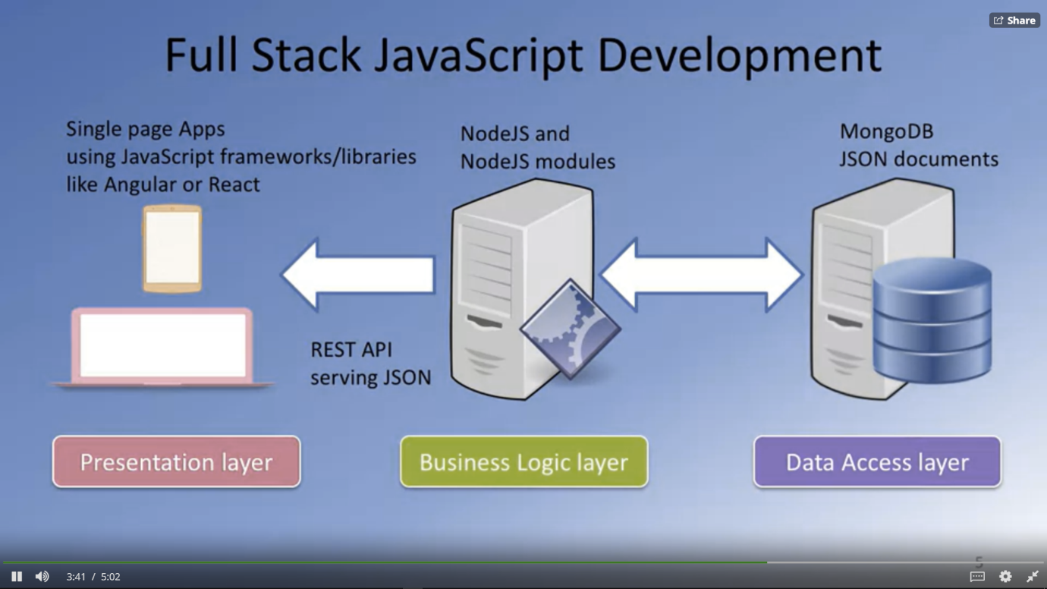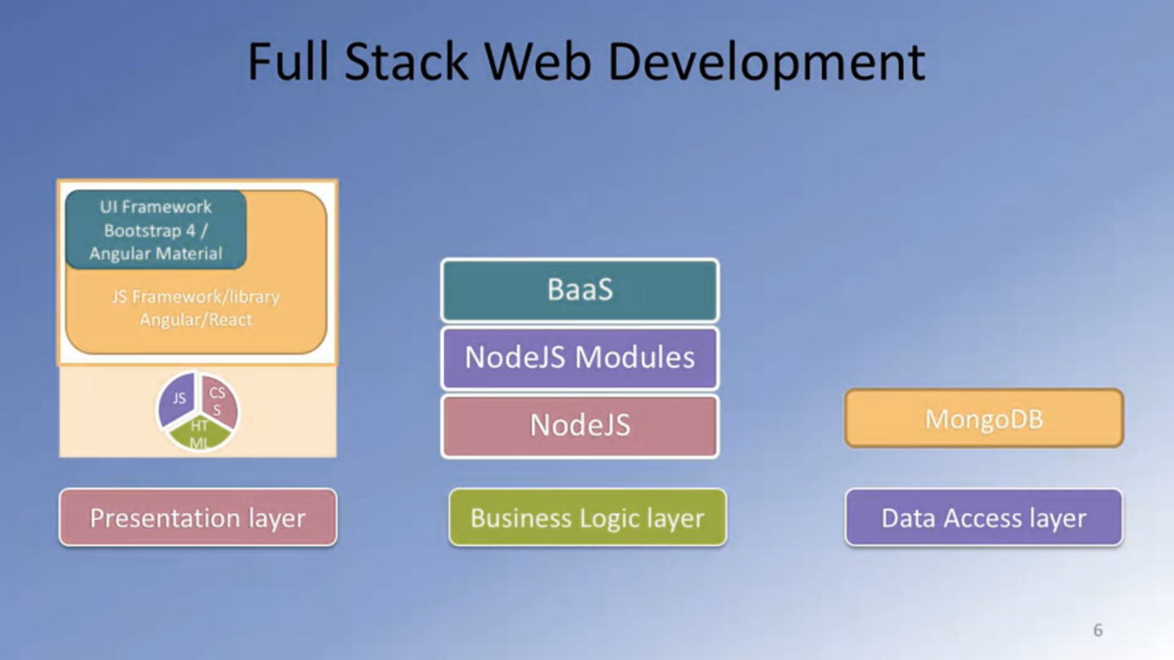

# **Full Stack Web Development: Additional Resources**

### Useful Links

* [What is a Full Stack developer?](http://www.laurencegellert.com/2012/08/what-is-a-full-stack-developer/)
* [Wait, Wait… What is a Full-stack Web Developer After All?](http://edward-designer.com/web/full-stack-web-developer/)
* [The Myth of the Full-stack Developer](http://andyshora.com/full-stack-developers.html)
* [Multi-tier Architecture](https://en.wikipedia.org/wiki/Multitier_architecture)
* [What is the 3-Tier Architecture?](http://www.tonymarston.net/php-mysql/3-tier-architecture.html)